LAB PROGRAMS

NAME: M.SAI HARSHITHA
REG.NO: 192424408
COURSE CODE: DSA0502
COURSE NAME: QUERY PROCESSING FOR DATASCIENCE

7.Write a Pandas program to create a bar plot of the trading volume of Alphabet Inc. stock between two specific dates.
Aim:
To write a Pandas program to create a Pivot Table and find the maximum and minimum sale value of the items.
Algorithm:
- Import the Pandas library.
- Create a DataFrame containing item sales data.
- Save the DataFrame as a CSV file.
- Read the CSV file.
- Display the sales data.
- Create a Pivot Table using the Item column.
- Find and display the maximum and minimum sale values.
Code:
import pandas as pd
sales = pd.DataFrame({
"Item": ["Pen", "Pen", "Book", "Book", "Pencil", "Pencil"],
"Sale": [100, 150, 300, 250, 80, 120]
})
sales.to_csv("sales.csv", index=False)
df = pd.read_csv("sales.csv")
print("Sales Data:")
print(df)
pivot = pd.pivot_table(df,
index="Item",
values="Sale",
aggfunc=["max","min"])
print("\nMaximum and Minimum Sale Value")
print(pivot)
Output:
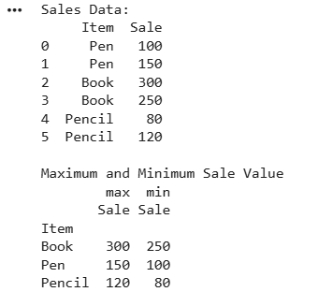

8.Write a Pandas program to create a Pivot table and find the item wise unit sold.
Aim:
To write a Pandas program to create a Pivot Table and find the item-wise units sold.
Algorithm:
- Import the Pandas library.
- Create a DataFrame containing item sales data.
- Save the DataFrame as a CSV file.
- Read the CSV file.
- Display the sales data.
- Create a Pivot Table using the Item column.
- Display the total units sold for each item.

Code:
import pandas as pd
sales = pd.DataFrame({
"Item": ["Pen", "Pen", "Book", "Book", "Pencil", "Pencil"],
"Units": [10, 15, 20, 25, 12, 18]
})
sales.to_csv("sales.csv", index=False)
df = pd.read_csv("sales.csv")
print("Sales Data:")
print(df)
pivot = pd.pivot_table(df,
index="Item",
values="Units",
aggfunc="sum")
print("\nItem Wise Units Sold")
print(pivot)
Output:
